Data Descriptions for recent-grads.csv

|  |  |
| --- | --- |
| **Header** | **Description** |
| Rank | Rank by median earnings |
| Major_code | Major code, FO1DP in ACS PUMS |
| Major | Major description |
| **Major_category** | Category of major from Carnevale et al |
| Total | Total number of people with major |
| Sample_size | Sample size (unweighted) of full-time, year-round ONLY (used for earnings) |
| **Men** | Male graduates |
| **Women** | Female graduates |
| ShareWomen | Women as share of total |
| Employed | Number employed (ESR == 1 or 2) |
| Full_time | Employed 35 hours or more |
| Part_time | Employed less than 35 hours |
| Full_time_year_round | Employed at least 50 weeks (WKW == 1) and at least 35 hours (WKHP >= 35) |
| Unemployed | Number unemployed (ESR == 3) |
| **Unemployment_rate** | Unemployed / (Unemployed + Employed) |
| **Median** | Median earnings of full-time, year-round workers |
| **P25th** | 25th percentile of earnigns |
| **P75th** | 75th percentile of earnings |
| College_jobs | Number with job requiring a college degree |
| Non_college_jobs | Number with job not requiring a college degree |
| Low_wage_jobs | Number in low-wage service jobs |

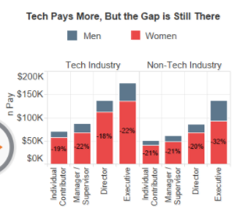

Horizontal bar plot

Y - Major category

X – Earning/Number of graduate

**X: Major category (STEM – NON-STEM)**

**Y: Number of graduates**

**(Two columns) Men and Women**

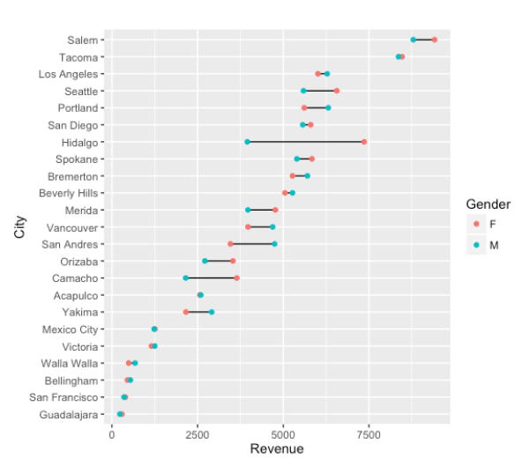<https://www.payscale.com/data-packages/gender-pay-gap/women-in-tech>

Box plot

Y: Earning X: STEM/NON-STEM

Scatter plot

Y: Unemployment rate

X: Median earning

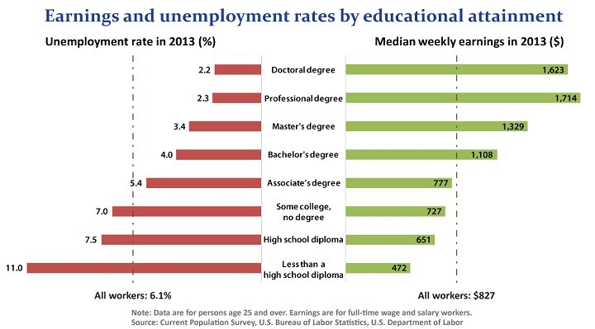Scatter – Major (Color – STEM)

Trendline

